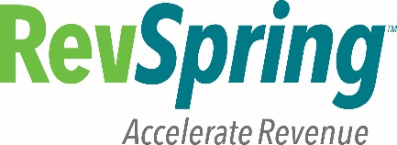

**Certification of Understanding**

Security Training - 2017

I have read the following sections entitled:

* + **Sanctions for Unauthorized Disclosure**
  + **Civil Damages for Unauthorized Disclosure**

These documents explain potential consequences for employees who violate the company’s security policies and procedures for safeguarding IRS information which comply with IRS Publication 1075. It is RevSpring’s responsibility to maintain this authorization for each employee of the company, and employees will be required to annually validate their compliance with IRS Publication 1075.

I certify that I have read and understand the attached Publication 1075 excerpts.

**NAME**: Pravallika Gongati________________________________

**DEPARTMENT**: _Configuration Analysts_________________________

**SIGNATURE**: ___________________________________________

**DATE**: _02/09/2018______________________________________